**Khulna University of Engineering & Technology**



**CSE-3210: Database System Laboratory**

**Report : Traffic Signal Management System**

**Submitted To: Submitted By:**

Md. Abdus Salim Mollah Farjana Afroz

Assistant Professor Roll: 2009032

Department of CSE Year: 3rd

KUET, Khulna, Bangladesh Semester: 2rd

Ms. Dola Das

Assistant Professor

Department of CSE

KUET, Khulna, Bangladesh

**Objectives:**

* To efficiently manage traffic flow by monitoring and controlling traffic signals
* To prioritize emergency vehicles to reduce delays during emergencies
* To monitor vehicle density at intersections for real-time traffic analysis
* To provide a reliable database system for recording and querying traffic-related data
* To enable smooth coordination between traffic signals and emergency vehicle priorities

**Introduction:**

The **Traffic Signal Management System Database** is designed to address the challenges of urban traffic control. With increasing numbers of vehicles, it is crucial to automate traffic signal management, monitor vehicle density, and prioritize emergency services. This database system is structured to manage traffic signals, record vehicle information, and facilitate real-time decision-making at intersections. It enhances traffic management efficiency while ensuring emergency vehicles are given priority access when necessary.

**User Manual:**

**1. Prerequisites**

* **Oracle Database Setup**: Ensure Oracle Database is properly installed and running.

#### 2. Database Setup

* Use the provided SQL scripts to create necessary tables and insert sample data.
* The database includes the following main tables:
  + **INTERSECTIONS**: Stores intersection data.
  + **TRAFFIC_SIGNALS**: Stores traffic signal details.
  + **VEHICLES**: Stores vehicle information.
  + **EMERGENCY_VEHICLES**: Stores data for emergency vehicles.
  + **TRAFFIC_DENSITY_LOG**: Logs vehicle density at intersections.

**3. Key SQL Operations**

* **Insert**: Add new records to the system (e.g., new vehicles, signals).
* **Select**: Retrieve data for vehicle status, signal states, etc.
* **Update**: Modify existing records (e.g., change signal timing or vehicle details).
* **Delete**: Remove records as needed (e.g., clear outdated traffic data).

**4. PL/SQL Operations**

* Use **FOR** and **WHILE** loops for batch insertion or updates.
* Apply **IF** conditions for complex logic (e.g., emergency vehicle prioritization).
* Manage data deletion based on specific criteria (e.g., clearing old logs).

**Schema & ER Diagram:**

The **ER diagram** illustrates the relationships between entities in the **Traffic Signal Management System**. Key relationships include:

* **Intersections to Traffic Density Logs** (1-to-many): Each intersection can have multiple density logs recorded at different times.
* **Intersections to Vehicles** (1-to-many): Each intersection has multiple vehicles passing through it.
* **Vehicles to Emergency Vehicles** (1-to-many): A vehicle can be categorized as an emergency vehicle with specific priority status.
* **Intersections to Traffic Signals** (1-to-many): Each intersection is associated with multiple traffic signals controlling traffic flow.

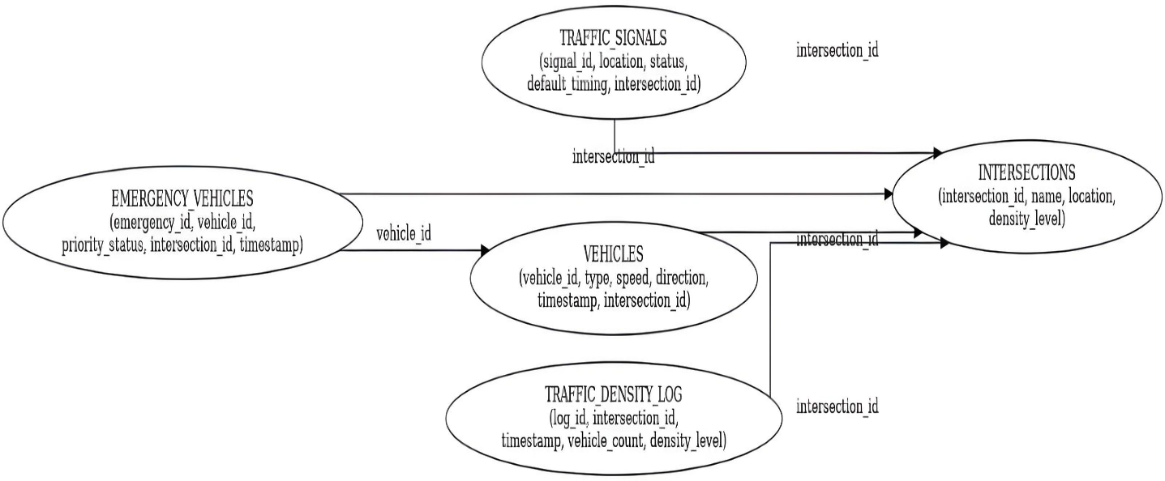

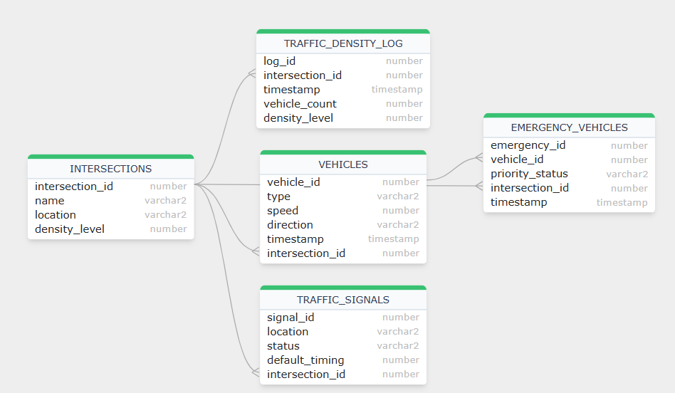

**Result Analysis:**

The traffic management system has various components like intersections, traffic signals, vehicle data, and emergency vehicles. The database tables define the structure for storing and managing the following data:

1. **Intersections**: Locations with a density level (1-5) that indicates traffic congestion.
2. **Traffic Signals**: Each intersection has a signal with a status (GREEN, YELLOW, RED) and a default timing.
3. **Vehicles**: Various vehicle types (Car, Emergency, Bus, etc.) with speed, direction, and intersection.
4. **Traffic Density Log**: Logs vehicle counts and density levels at intersections.
5. **Emergency Vehicles**: Tracks emergency vehicles with priority status (High, Medium, Low) at intersections.

The queries and operations focus on:

* **Vehicle and Emergency Vehicle Querying**: Retrieves vehicle details based on type and priority, checks vehicle speed against emergencies, and identifies intersections with emergencies.
* **Joins**: Combines data from different tables like vehicles and intersections, and vehicles and emergency vehicles.
* **PL/SQL Operations**: Includes:
  + **Counting vehicles** in high-density intersections.
  + **Checking if a specific vehicle passed** through an intersection.
  + **Updating traffic signal status** based on vehicle density.
  + **Adjusting signal timing** based on density.
  + **Changing signals for emergency vehicles**.
  + **Resetting traffic signals** after peak hours.

This system dynamically manages traffic signals based on traffic density and emergency vehicle needs to improve traffic flow and safety.

**Application:**

The Traffic Signal Management System Database can be applied in several real-world scenarios. Here are its primary applications:

1. **Real-Time Traffic Management**

* **Dynamic Signal Control:** The system can adjust traffic signals based on the density of vehicles at intersections to optimize traffic flow.
* **Emergency Vehicle Prioritization:** Automatically prioritizes emergency vehicles like ambulances, fire trucks, and police cars, ensuring they pass through intersections without delay.

1. **Traffic Analytics**

* **Vehicle Count Analysis:** Generates reports on vehicle counts across intersections, helping city planners analyze traffic trends and congestion patterns.
* **Signal Effectiveness Assessment:** Monitors and evaluates the effectiveness of traffic signals at various intersections to improve efficiency.

1. **Incident Management**

* **Emergency Alert System:** Detects emergency vehicles in transit and sends alerts to nearby intersections to clear traffic or change signal status.
* **Accident Handling:** Quickly identifies locations of stopped or inactive vehicles for dispatching assistance.

1. **Urban Planning and Development**

* **Infrastructure Planning:** Provides data on high-traffic areas, aiding in infrastructure development, such as adding lanes, overpasses, or new intersections.
* **Route Optimization:** Helps city planners optimize routes and recommend alternative paths for heavy vehicles to reduce congestion.

1. **Law Enforcement Support**

* **License Plate Tracking:** Stores and retrieves vehicle data to assist law enforcement in tracking vehicles related to crimes or violations.
* **Traffic Violations Monitoring:** Integrates with monitoring systems to record vehicles violating traffic rules, like running red lights.

1. **Public Safety Enhancement**

* **Minimizing Emergency Response Time:** Prioritizes routes for emergency vehicles, reducing response times to incidents.
* **Reducing Traffic Accidents:** By managing the flow of vehicles more effectively, the system helps reduce traffic accidents, especially at critical intersections.

1. **Environmental Benefits**

* **Reducing Emissions:** Optimized signal timings reduce vehicle idling time, leading to lower carbon emissions and improved air quality.
* **Promoting Sustainable Transportation:** Encourages smoother traffic flow, reducing fuel consumption and overall transportation costs

1. **Integration with Smart City Initiatives**

* **IoT Integration:** Can be integrated with IoT devices for real-time monitoring and decision-making.
* **Data Sharing:** Shares real-time data with other smart city systems, like public transportation and parking management.

This database is critical for ensuring efficient, safe, and sustainable traffic management in urban areas, addressing both immediate operational needs and long-term planning objectives.

**Discussion:**

This project covers a variety of essential SQL and PL/SQL operations commonly used in database management systems, applied to the **TRAFFIC_SIGNAL,** TRAFFIC_DENCITY_LOG, **VEHICLES, INTERSECTIONS,** and **EMERGENCY_VEHICLES** tables. By implementing these operations on the traffic management system’s database, we demonstrate how to effectively manage and manipulate traffic-related data in an Oracle environment. Key operations performed, such as **ALTER TABLE, INSERT, UPDATE**, and **DELETE,** provide foundational skills essential for any database administrator or developer. These operations enable the creation, modification, and removal of data across multiple tables, essential for managing dynamic traffic data. The use of **joins** (INNER JOIN, LEFT JOIN, RIGHT JOIN) is particularly important as it allows us to combine data from multiple tables, such as linking vehicle data with intersection information and emergency vehicle status. This demonstrates the importance of extracting meaningful insights from related data across different entities, such as vehicle density, traffic signal status, and emergency vehicle prioritization. Additionally, the **UNION** and **INTERSECT** set operations are applied to efficiently merge or find common results from different queries. These operations are critical in scenarios where we need to consolidate traffic data from multiple sources or identify common elements, such as emergency vehicle movements. PL/SQL operations, including **loops** (FOR, WHILE) and **conditional statements**, allow us to automate tasks and enhance the dynamism of the system. For instance, **bulk record insertion** is optimized using loops, especially when processing large volumes of traffic data. **Nested loops** are used to handle complex operations across multiple tables, such as updating traffic signals based on real-time traffic density or prioritizing emergency vehicles. The combination of SQL and PL/SQL techniques demonstrates how to manage and control traffic signals and vehicle movements efficiently in an intelligent traffic management system, where real-time data processing and automation are critical for maintaining smooth and safe traffic flow.

**Conclusion:**

The **Traffic Signal Management System Database** offers a robust solution for addressing urban traffic challenges. With a strong emphasis on real-time traffic updates, emergency vehicle prioritization, and automated traffic signal control, this system plays a crucial role in improving road safety and alleviating congestion. By efficiently managing traffic flow and providing timely adjustments based on vehicle density and emergency vehicle movements, this system ensures that cities can achieve smoother traffic management. Additionally, the ability to prioritize emergency vehicles enhances response times, ultimately contributing to faster emergency service deployment. By implementing such a system, urban areas can experience not only improved traffic flow but also enhanced overall public safety.